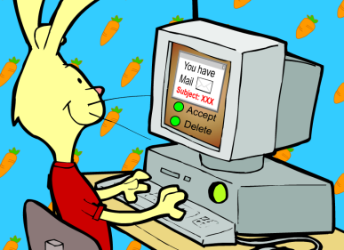
- NEVER Give out
Personal Information.
- NEVER Meet a Friend You Only Know Online In Person.
- NEVER Respond to Messages That Make You Feel Uncomfortable.

- Don’t spend too much time online. Ask your parents.
- Don’t be mean online.
- Avoid inappropriate materials and ‘bad’ friends on web sites, Facebook, chat, email, and phone.
How to Be Safe on THE Internet

Who use Internet? Own computer?
Email, chat, Facebook, web cam, phone… is usually not private. Friends see it, someone else see it.
Online friend. Don’t know who they are and good intention or not. Can’t trust stranger who send email, chat, talk to, gifts. SAFE TOUCH. Avoid You may find bad things/material/people on the Web make you uncomfortable.

SAFE TOUCH school, home. Look at your sheet SAFE on the internet how to stay safe.
• NEVER give out personal information. Ask for your name.
address, phone number, age, school? Give it out? NO. name Let your parent do that.
• NEVER meet a friend you only know online. Online is same as stranger. Stranger ask to meet you? Say NO. Even your friend. Let parents decide who you meet talk to. If I, c. Ha` call. Must tell parent. Stranger, I don’t know you.
• NEVER respond to messages that make you feel uncomfortable
or hurt your feelings. Ignore these messages and tell a parent, teacher, HTs you trust right away.

------

Just NOT good for you or get you in trouble.
((Older teens that may choose not to tell a parent and go alone should at least go with a friend and meet in a public place.)
)
that isoffensive, obscene, violent

You and your family may unexpectedly and
unintentionally find material on the Web that is
offensive, obscene, violent
friends’ names.

