Eucharist and Holy Scripture – Sources of Life for the Soul
4 Parts of a Sunday Mass:
- Introductory Rites
- Liturgy of the Word: from First Reading to General Intercession (Prayer of the Faithful)
- Liturgy of the Eucharist: from the Preparation of Gifts for the altar to prayer after Communion
- Concluding Rites
Questions:
- How does the Holy Scripture feed your soul?
- How does the Holy Eucharist feed your soul?
- Why are the Liturgy of the Word and the Liturgy of the Eucharist a single act of worship?

Holy Scripture is more than just for Mass. It also applies to our daily lives.
Match the situation to a possible scripture verse that might help you.
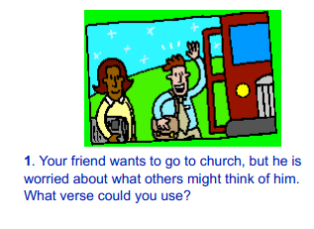 | Ephesians 2: 8,9  For by grace you have been saved through faith, and this is not your own doing; it is the gift of God— not the result of works, so that no one may boast.
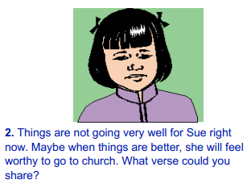 | John 8:12  Again Jesus spoke to them, saying, ‘I am the light of the world. Whoever follows me will never walk in darkness but will have the light of life.’
 | Luke 18:14b  I tell you, this man went down to his home justified rather than the other; for all who exalt themselves will be humbled, but all who humble themselves will be exalted.’
 | Matthew 5:10  ‘Blessed are those who are persecuted for righteousness’ sake, for theirs is the kingdom of heaven.
 | Psalm 55:22  Cast your burden on the Lord,  and he will sustain you;  he will never permit  the righteous to be moved.
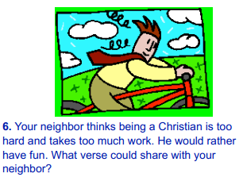 | Ephesians 6: 1-3  Children, obey your parents in the Lord, for this is right. ‘Honour your father and mother’—this is the first commandment with a promise: ‘so that it may be well with you and you may live long on the earth.’

Talking point:
- Show the Powerpoint: ask know most of it?
- Go through quickly Can you divide? Reading ? Receiving communion?
- Participate in it: Do Sunday reading. How to receive communion.
Why are we doing all of this? Going with the motion
- How does the Holy Scripture feed your soul? Word of God guide our lives and give us peace.
- How does the Holy Eucharist feed your soul? Because Chist true present in the Eucharist. Receive it daily.
- Why is the Liturgy of the Word and the Liturgy of the Eucharist a single act of worship? Love your mom? Love Kenny? Know to be closer.
Word of God, Receiving Communiion is enough? Live our daily lives?
Situation in our lives? Bring out the Bible? Influcence Script is silence? Act out how the word of God influence u?
Good: how to apply Scripture and learn your acting skills.
Music.
Situations:

